AFAB -

Functionality

The planned depreciation is posted to the relevant general ledger control accounts when you run the periodic depreciation-posting run.

Scenario
This posting run uses a background session (NOT a Batch input session since the existence of parallel currencies requires FI Direct posting) to post the planned depreciation for each posting level for each individual asset as a lump sum amount.
When the system posts depreciation, it creates collective documents. It does not create separate documents for each asset.

Requirements
Previous Asset Fiscal Year is closed and previous periods depreciation have been posted.

Menu Path | Accounting → Financial Accounting → Fixed Assets → Periodic Processing → Depreciation Run → AFAB - Execute
Transaction Code | AFAB

1. Double Click on AFAB - Execute

Depreciation Posting Run

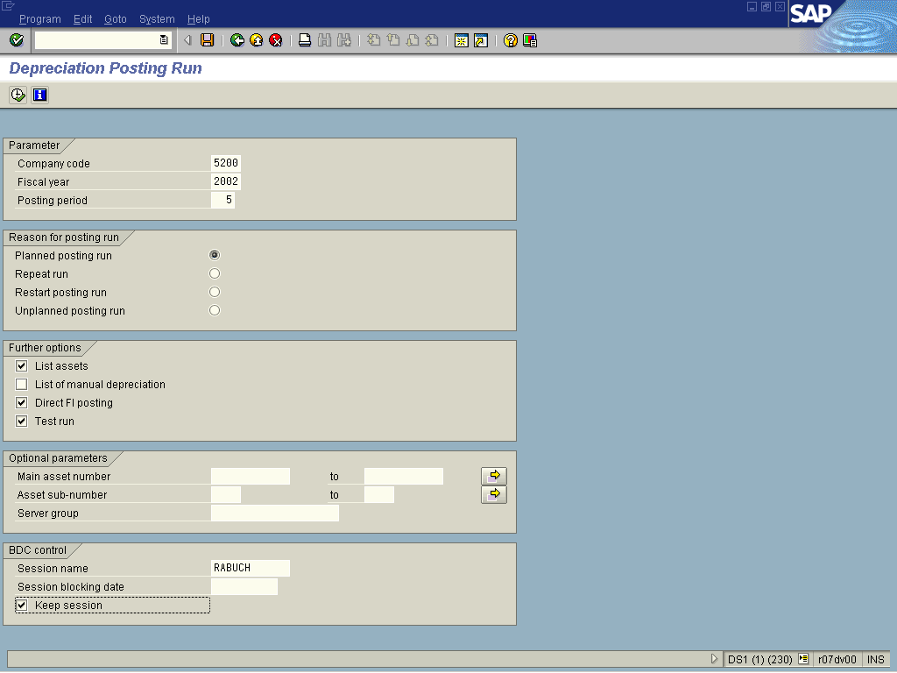
2. Update the following fields:
Field Name | Field Description | Values
Company code | Code identifying the company purchasing the material | Example: 5200
Fiscal year | Period, 12 months as a rule, for which the company is to create its inventory and balance sheet. | Example: 2001
Posting period | Fiscal month when the transaction posts to the General Ledger | Example: 05
3. Click <checkbox> List assets to provide details of depreciation posted per asset.
4. Click <checkbox> Test run .
5. Click <checkbox> Keep session to retain the session once the batch input job has been posted.
6. Click Execute .

Limitation online

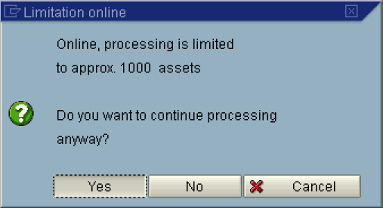

Note: This message is only displayed in Test mode. In productive mode i.e. The test run radio button is off, the system requires that the session be run in Background.
7. Click the Yes Button.
Depreciation Posting Run for company code 5200

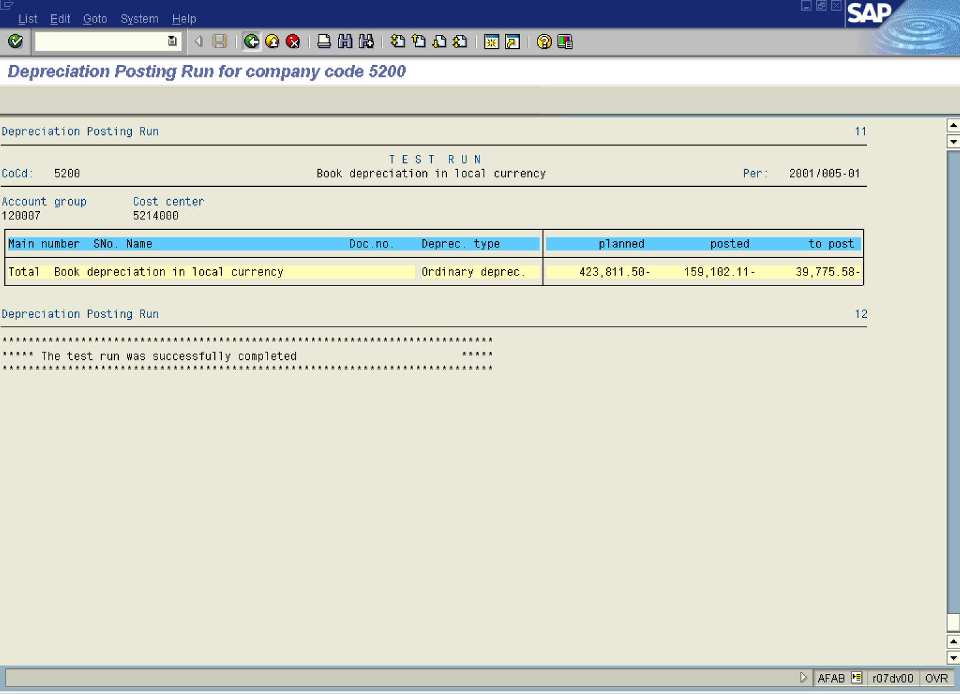

Note: The system displays a list of planned depreciation. Once you have confirm that the depreciation to be posted is correct, proceed in productive mode. i.e. By turning off the “test” mode radio button.
8. Click Back to return back to the depreciation posting run screen.
Depreciation Posting Run

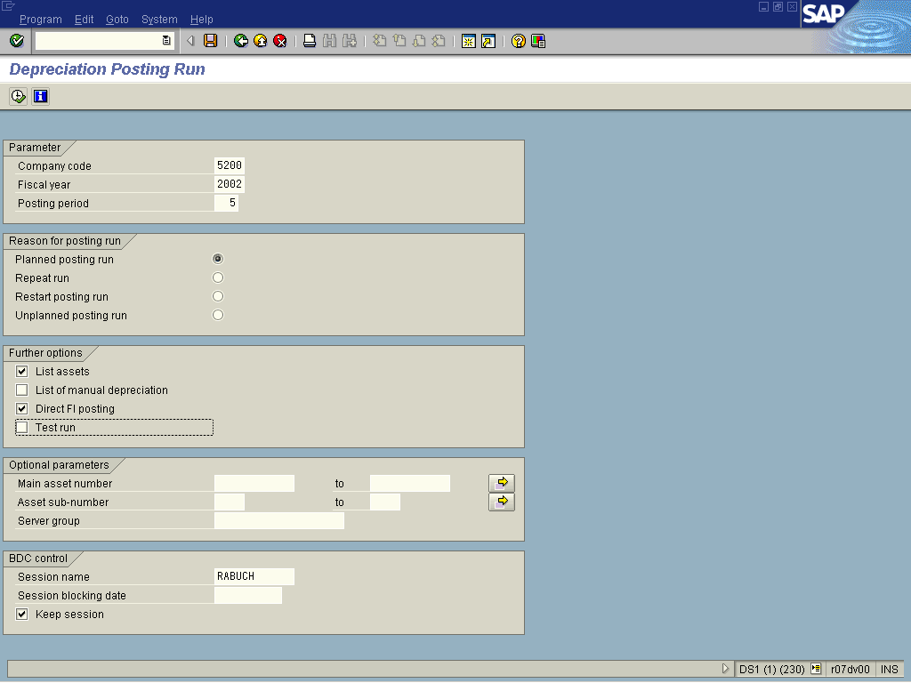

9. De-activate by clicking the <checkbox> Test run .

10. Select ProgramExecute in background.

Note: Productive depreciation run MUST be done in ”Background".

Background Print Parameters

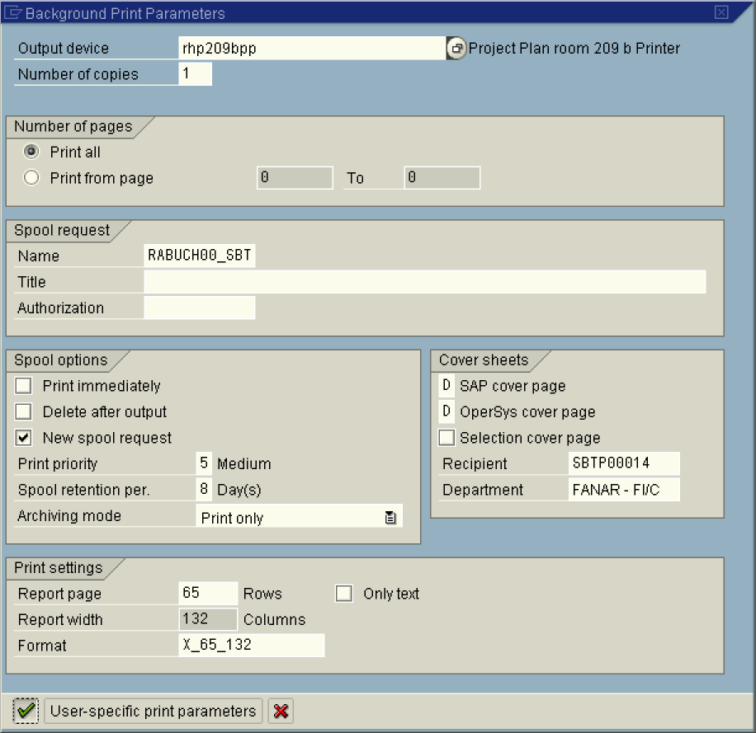

Note: Ensure that the "Print Immediately" radio button is off. If this is on and the "List Assets" radio button on the initial screen is on - a complete list of depreciation per asset will be printed. Unless required - this list can be downloaded instead of printed.

11. Click the Enter button to confirm your entries.

Start Time

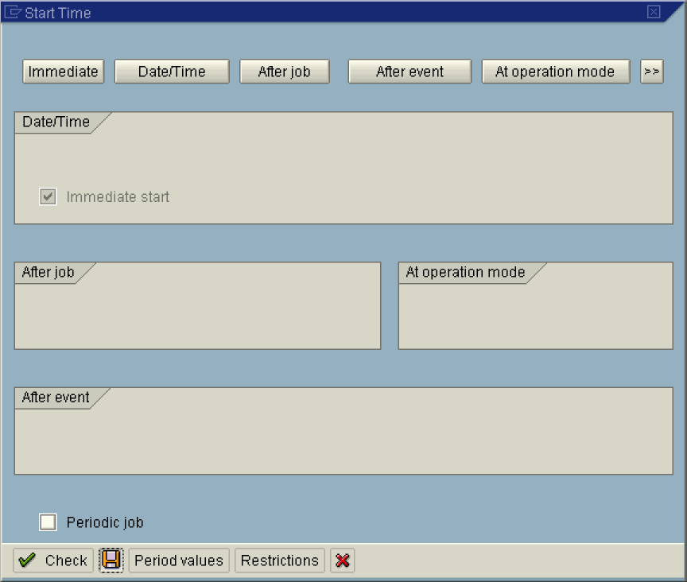

12. Click Immediate button.

Note: To run the job at a later time or after a specific event, select the relevant button. or .

13. Click the Save button.

Depreciation Posting Run

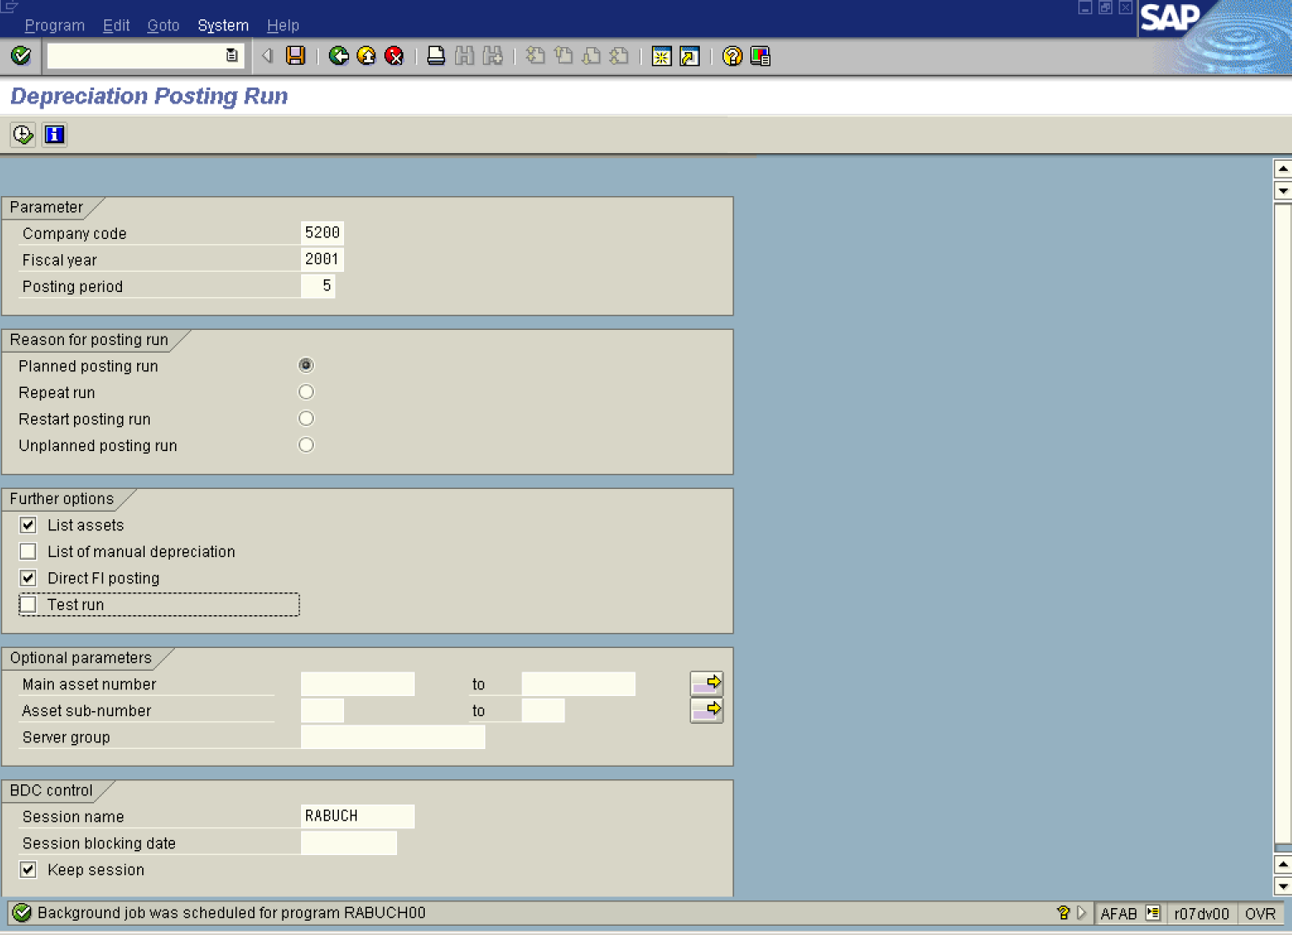

14. To view the status of the run, use the following menu path: System  Services  Jobs  Job overview.

Simple Job Selection

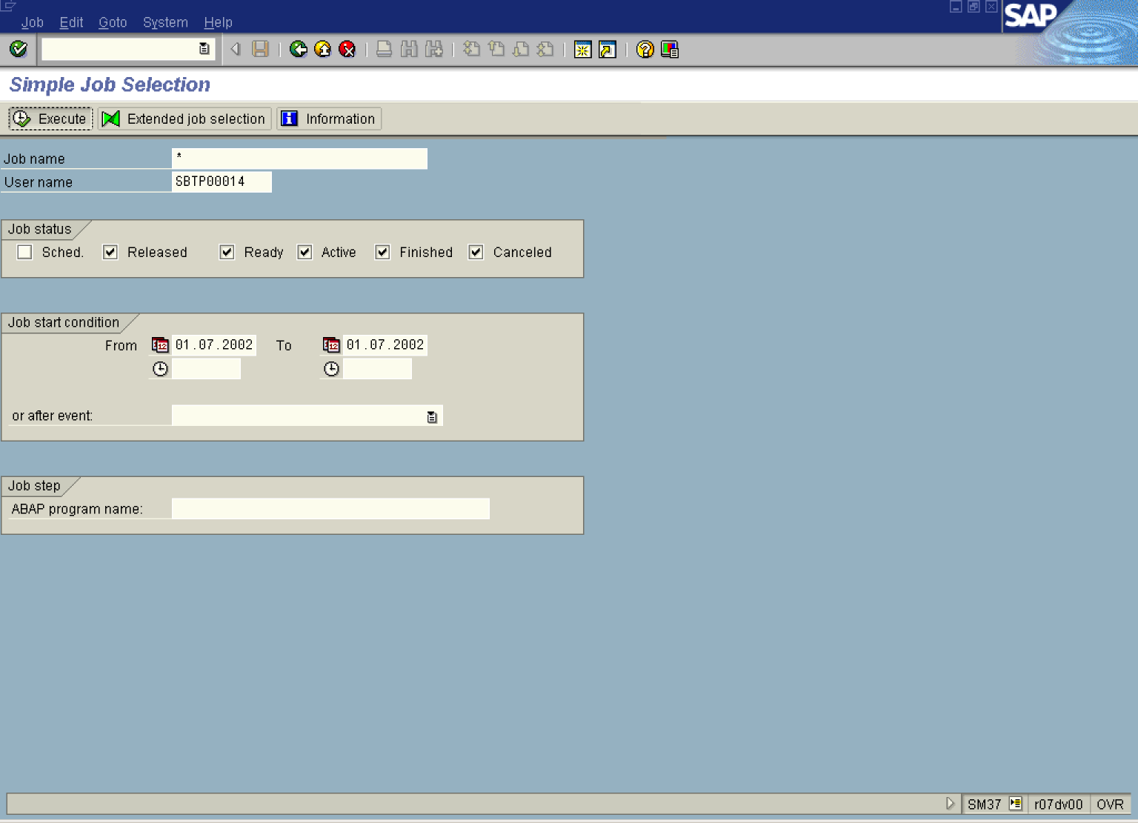

15. Click Execute .

Job Overview

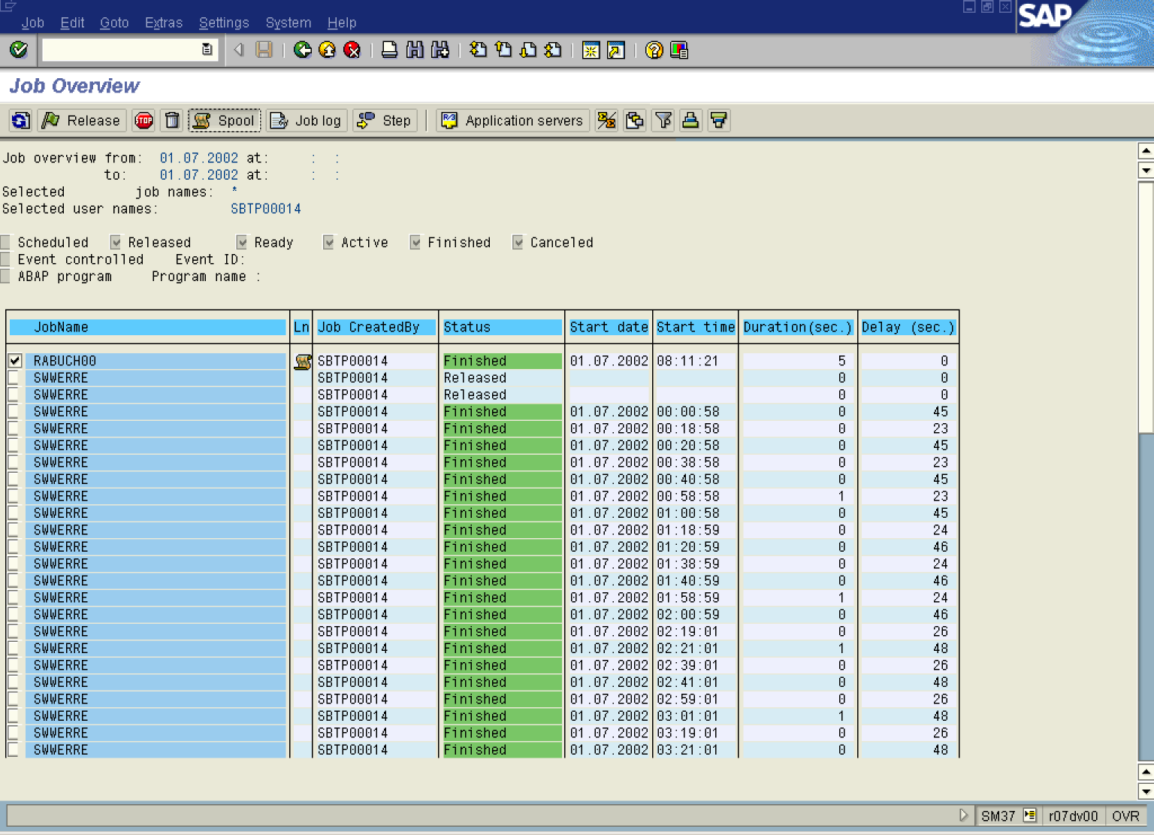

16. Select the RABUCH00 session by clicking on the button.
17. Click Spool Button .

Output Controller: List of Spool Requests

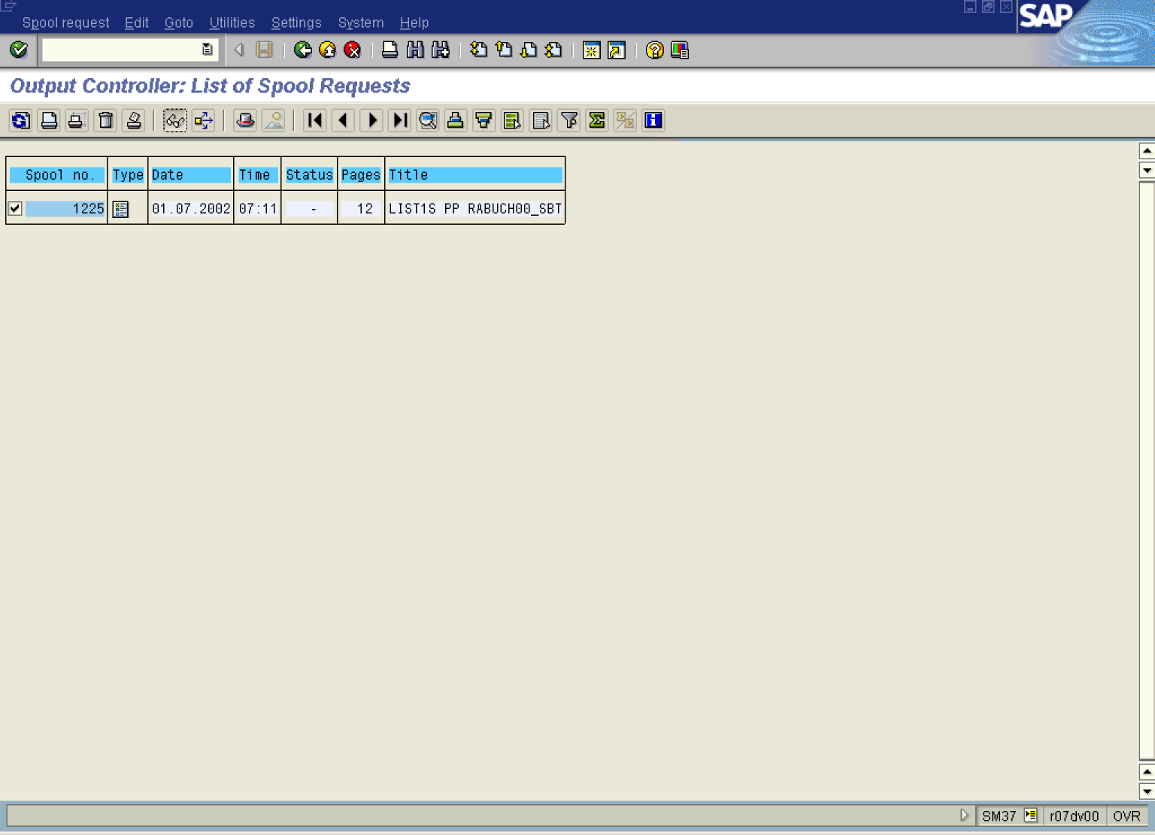

18. Click 1225 Button .
19. Click Display .

Graphical display of spool request 1225 in system DS1

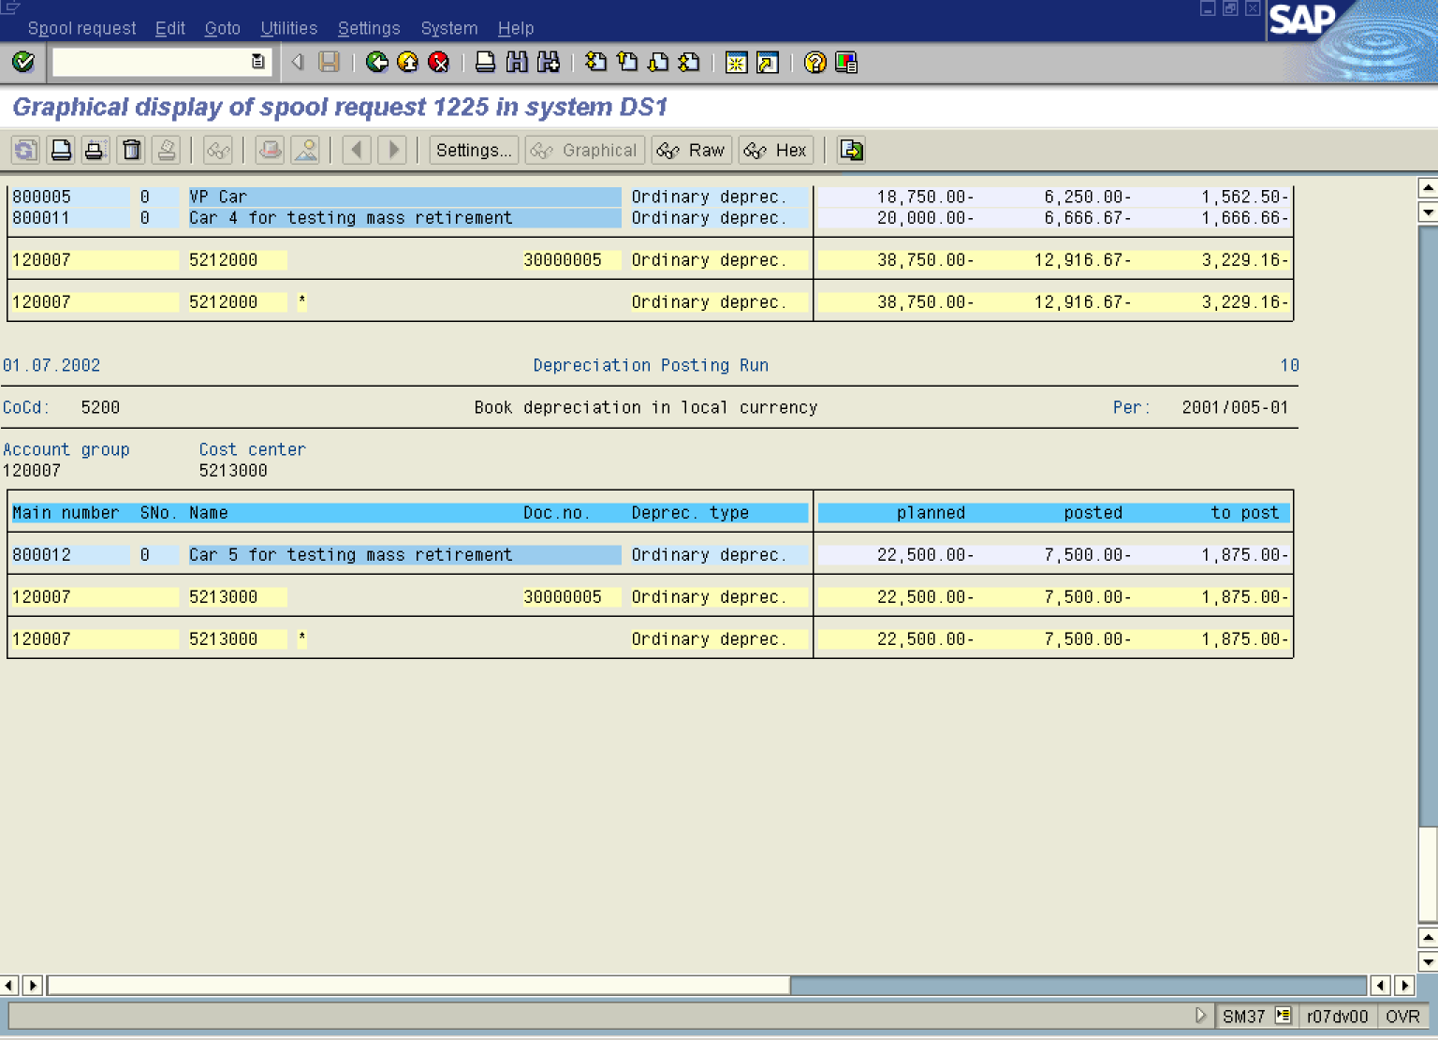
20. The system displays a detailed list of the depreciation posted per asset.

